**Table of Content**

**Travely**

Chapter 1: Introduction to the Problem..............................................................................................….….8

Introduction.................................................................................................................................... 8

Purpose........................................................................................................................................... 8

Objective ........................................................................................................................................ 8

Existing Solution............................................................................................................................ 8

Proposed Solution.......................................................................................................................... 8

Chapter 2: Software Requirement Specification......................................................................................... 8

1. Introduction................................................................................................................................ 8

1.1. Purpose ............................................................................................................8

1.2. Scope ...............................................................................................................8

1.3. Definitions, acronyms, and abbreviations .......................................................9

1.4. References .......................................................................................................9

1.5. Overview .........................................................................................................9

2. Overall description ....................................................................................................................9

1.2. Product perspective .........................................................................................9

1.3. Product functions ...........................................................................................10

1.4. User characteristics ....................................................................................... 11

1.5. Constraints......................................................................................................11

1.6. Assumptions and dependencies .....................................................................11

1.7. Apportioning of requirements ...................................................................... 11

2. Specific requirements..............................................................................................................12

2.1. Functional Requirement ...............................................................................12

2.2. Non-functional Requirements ......................................................................12

3. Appendixes ............................................................................................................................12

4. Index.......................................................................................................................................12

Chapter 3: Use Case Analysis.................................................................................................................. 13

Chapter 4: Design................................................................................................................................... 15

4.1. Architecture Diagram......................................................................................................... 15

4.2. ERD with data dictionary.................................................................................................... 15

4.3. Data Flow diagram............................................................................................................. 16

4.3.1. The level 0........................................................................................................ 16

4.3.2. The level 1........................................................................................................ 17

4.4. Class Diagram................................................................................................................... 18

4.5. Activity Diagram............................................................................................................... 19

4.6. Sequence Diagram............................................................................................................ 20

4.7. Collaboration Diagram...................................................................................................... 21

4.8. State Transition Diagram................................................................................................... 22

4.9. Component Diagram......................................................................................................... 23

4.10. Deployment Diagram...................................................................................................... 24

**Chapter 1: Introduction to the Problem**

**Introduction**

A lot of people are passionate about traveling but they cannot follow their passion because the traveling packages they are offered are very expensive they lack the basic information required for their traveling needs and even their safety needs are not satisfied. For traveling most people usually visit web portals or visit a travel agent. There are few already existing portals but they are not intelligent enough to provide them fully customized and intelligent solution. So there is serious need in the travel industry for custom package building mechanism/portal that is intelligent enough in real time and can offer interesting and desired advice.

**Purpose**

The development of this project is to provide fully customized packages for travel passionate people and to make travel as safe as possible. Our portal will help people pre plan their trip in an easy way by providing them the intelligent advise in order to make their journey memorable, pleasurable and most of them all without compromising their insured safety nets.

**Objective**

Customer satisfaction and trust is our main objective in order to achieve our objectives we make trips memorable, comfortable and pleasurable by providing them fully customizable traveling packages.

**Existing solution**

Trip Advisor, Cheap O Air, Make my Trip. These are the existing available solutions and they have certain limitations and need excess work. Mainly their packages are not customizable specially while travelling there are additional needs for insurance coverage and/or accommodation selection, and/or car rentals are planned.

**Purposed solution**

Travely is an automated portal that is based on artificial intelligence techniques to data extraction from web and helps the person who is planning a trip. This platform will though help design custom packages: flight booking with stop-overs vs price, accommodation advice in each stop over, and also possibly if traveler can avail car rental facility and what type of insurance should be accepted. Using this platform we shall use techniques from AI, semantics and data mining to help develop this portal. Specially if a traveler needs a comprehensive travel plan.

**Chapter 2: Software Requirement Specification**

**1. Introduction**

**1.1 Purpose**

The Software Requirements Specification is designed to document and describe the agreement between the customer and the developer regarding the specification of the software product requested. The primary purpose is to provide a clear and descriptive “statement of user requirements” that can be used as a reference in further development of the software system. This document is broken into a number of sections used to logically separate the software requirements into easily referenced parts. This Software Requirements Specification aims to describe the Functionality, External interfaces, Attributes and Design Constraints imposed on Implementation of the software system described throughout the rest of the document. Throughout the description of the software system, the language and terminology used should unambiguous and consistent throughout the document.

This portion of document is intended for technical users and developers of “Travely” (Web Portal).

**1.2 Scope**

People want to travel yet they must go through different web based portals or go through travel agents, which in most cases don’t cater to their specific needs nor offer local packages. Travely is an automated portal that is based on artificial intelligence techniques to data extraction from web and helps the person who is planning a trip.

**1.3. Definitions, acronyms, and abbreviations**

**1.4. References**

**1.5. Overview**

**1.2. Overall description**

**1.1. Product perspective**

**1.1.1. System interfaces +987\**

**1.1.2. User interfaces**

**1.1.3. Hardware interfaces**

**1.1.4. Software interfaces**

**1.1.5. Communications interfaces**

**1.1.6. Memory**

**1.1.7. Operations**

**1.1.8. Site adaptation requirements**

**1.3. Product functions**

This platform will though help design custom packages: flight booking with stop-overs vs price, accommodation advice in each stop over, and also possibly if traveler can avail car rental facility and what type of insurance should be accepted. Using this platform we shall use techniques from AI, semantics and data mining to help develop this portal. Specially if a traveler needs a comprehensive travel plan.

ID: FR_001

Name: Add the starting point location

|  |  |  |  |
| --- | --- | --- | --- |
| Description | Input | Output | Work Flow |
| Add the starting point of journey | Enter the current location | Track the location | Enter the details or track by GPS |

ID: FR_002

Name: Add the destination point location

|  |  |  |  |
| --- | --- | --- | --- |
| Description | Input | Output | Work Flow |
| Add the destination point of journey | Enter the destination point | Track the destination point from database | Search for entered destination |

ID: FR_003

Name: Departure Date

|  |  |  |  |
| --- | --- | --- | --- |
| Description | Input | Output | Work Flow |
| Enter departure date | Select the date from poped calendar | Mark the date as destination | Mark the selected date for departure |

ID: FR_004

Name: Return Date

|  |  |  |  |
| --- | --- | --- | --- |
| Description | Input | Output | Work Flow |
| Enter return date | Select the date from pooped calendar | Mark the date as return | Mark the selected date for return |

ID: FR_005

Name: Number of Persons

|  |  |  |  |
| --- | --- | --- | --- |
| Description | Input | Output | Work Flow |
| Ask user the number of adults and children in a dropdown menu | Add or Subtract number of adults and children in given menu | Save number of persons | Select number of adults and children from a menu and save |

ID: FR_006

Name: Hotel

|  |  |  |  |
| --- | --- | --- | --- |
| Description | Input | Output | Work Flow |
| Select hotel on the base of destination | Click on hotel  Icon  Selection of hotel | Hotel selected | The user will select the hotel and it will be marked as selected |

ID: FR_007

Name: Room

|  |  |  |  |
| --- | --- | --- | --- |
| Description | Input | Output | Work Flow |
| Select no of rooms | Selection of room | Rooms selected | Select number of rooms from a dropdown menu |

ID: FR_008

Name: Room Type

|  |  |  |  |
| --- | --- | --- | --- |
| Description | Input | Output | Work Flow |
| Select type of room | Selection of room type | Given type of rooms i.e single bed, double bed, presidential suite | Select types of rooms from a dropdown menu |

ID: FR_009

Name: Flight

|  |  |  |  |
| --- | --- | --- | --- |
| Description | Input | Output | Work Flow |
| Select Flight | Click on Flight Icon | Selected flight | Enter the details of flights |

ID: FR_010

Name: select flight class

|  |  |  |  |
| --- | --- | --- | --- |
| Description | Input | Output | Work Flow |
| Select type of flight class | Selection type of class | Selected class  E.g. Economy, Premium, Business class, First class | Select class of flights from a dropdown menu |

ID: FR_011

Name: Save Conformation Flight

|  |  |  |  |
| --- | --- | --- | --- |
| Description | Input | Output | Work Flow |
| Click the save button | Book the Seat | Conformation the booking with popup message | Upon Selection of flights details |

ID: FR_012

Name: Save Conformation Hotels

|  |  |  |  |
| --- | --- | --- | --- |
| Description | Input | Output | Work Flow |
| Click the save button | Book the hotel | Conformation the booking with popup message | Upon Selection of hotel details |

ID: FR_013

Name: Save Conformation Rooms

|  |  |  |  |
| --- | --- | --- | --- |
| Description | Input | Output | Work Flow |
| Click the save button | Book the room | Conformation the booking with popup message | Upon Selection of room details |

ID: FR_014

Name: Insurance

|  |  |  |  |
| --- | --- | --- | --- |
| Description | Input | Output | Work Flow |
| If you want to avail the insurance then mark the insurance checkbox | Mark the checkbox | Show available options regarding insurance | Upon Selection of insurance details |

ID: FR_015

Name: Select Travel Insurance

|  |  |  |  |
| --- | --- | --- | --- |
| Description | Input | Output | Work Flow |
| If you want to avail the travel insurance then mark the insurance checkbox | Mark the travel insurance checkbox | Show available options regarding insurance | Upon Selection of travel insurance details |

ID: FR_016

Name: Select Flight Insurance

|  |  |  |  |
| --- | --- | --- | --- |
| Description | Input | Output | Work Flow |
| If you want to avail the flight insurance then mark the insurance checkbox | Mark the flight insurance checkbox | Show available options regarding insurance | Upon Selection of flight insurance details |

ID: FR_017

Name: Rental Service

|  |  |  |  |
| --- | --- | --- | --- |
| Description | Input | Output | Work Flow |
| If you want to avail the rental service then mark the rental service checkbox | Mark the rental service options | Show the list of rental services  E.g. Car, Motorbike, Van | Upon selection of rental service details |

ID: FR_018

Name: Search on given information

|  |  |  |  |
| --- | --- | --- | --- |
| Description | Input | Output | Work Flow |
| When the user provides the basic information i.e departure, arrival, etc.  It will search on that information | User inputs the departure location and destination including the check in and check out dates for hotels | It will show all the information related to the trip i.e airways, hotels, rentals, insurances, driving license eligibility | On the input of the user information the system will provide the matching information related to the provided knowledge |

ID: FR_19

Name: Search

|  |  |  |  |
| --- | --- | --- | --- |
| Description | Input | Output | Work Flow |
| User will be provided with the options to search for any provided service it will be given option to search for a specific flight or hotel for a provided destination | User inputs the destination and the service which needs to be searched | The searched information will be provided to the user | The user will input the information and the system will search the database for the information available and if present provide it to the user |

**1.4. User characteristics**

A user of this system is defined as any living person who has a need for travel and knowledge to explore internet portals to search specifics and plan the whole trip, using all possible and available resources.

**1.5. Constraints**

A user might be in a situation where the package is not offered, or may face other political or economical situation, wherein such situation no promotions are identified.

**1.6. Assumptions and dependencies**

Our portal will only be web based and the user will be able to book the packages.

**1.7. Apportioning of requirements**

The online selling of the airline tickets and the booking of accommodations purchase of insurance policies and rentals will not be possible until it is fully functional and under the license which will be delayed until future version of the system.

## 2. SPECIFIC REQUIRMENTS

**2.1. Functional Requirement**

* Airline booking
* Hotel booking
* Rental services
* Insurances

**2.2. Non Functional Requirement**

**2.2.1. Usability**

The portal will be user friendly it will be designed by keeping the HCI basic principles to make the usability as effective as it can be. The designed interface will be easy to learn how to use and easy to remember how to use.

**2.2.2. Reliability**

The system is totally reliable to use by any user the  data created in the system will be retained for a number of years without the data being changed by the system. The chances of system failure will be very low and in case if the system crashes it will have the ability to self recover.

**2.2.3. Performance**

The performance shall depend upon the Device’s processing speed, RAM and Screen Resolution. The internet speed is also necessary to obtain the high performance.

**2.2.4. Design constraints**

**2.2.5. Portability**

As this system is web based so the diversity of the hardware and software platforms on which the information system can run is very high as the system can run through any working computer or smart phone there is no special hardware or software requirement.

**2.2.6. Security**

The portal’s back-end servers shall only be accessible to authenticated administrators. The portal’s back-end databases shall be encrypted.

**2.2.7. Maintainability**

The source code developed for this portal shall be maintained in configuration management tool. Necessary changes will be made as per requirement.

**2.2.8. License Agreement**

As the system will be in development and evolution stages so there will be will be no license agreements of any kind

**3. Appendixes**

**4. Index**

**Chapter 3: Use Case Analysis**

**3.1. Register**

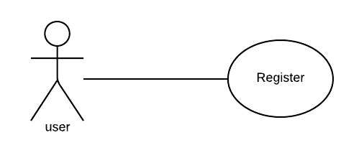

**Use case diagram detail:**

|  |  |
| --- | --- |
| Use Case ID | UC#01 |
| Use Case Name | Register |
| Description | Register to web portal |
| Primary Actor | User |
| Secondary Actor | Admin |
| Pre-Condition | none |
| Post-Condition | none |
| Basic Flow | Actor Action System Action |
|  | User Information. Register into Database  E.g. Name, cell No, Address, City... |
| Alternate Flow | none |

**3.2. User/Admin Login**

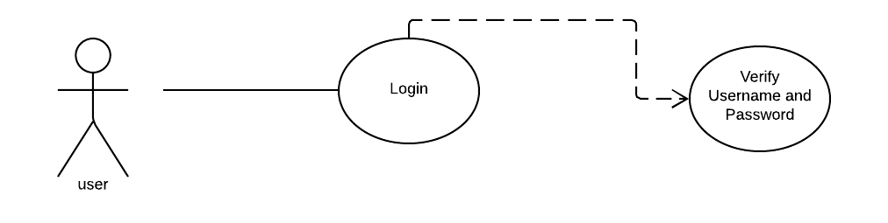

**Use case diagram detail:**

|  |  |
| --- | --- |
| Use Case ID | UC#02 |
| Use Case Name | Login |
| Description | Login to web portal |
| Primary Actor | User |
| Secondary Actor | Admin |
| Pre-Condition | none |
| Post-Condition | none |
| Basic Flow | Actor Action System Action |
|  | Input the username and password Return Output |
| Alternate Flow | none |

**3.3. Package**

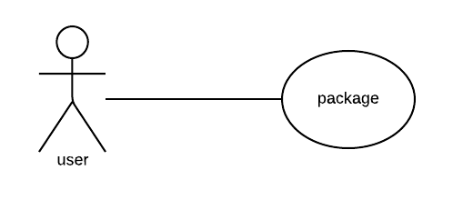

**Use case diagram detail:**

|  |  |
| --- | --- |
| Use Case ID | UC#03 |
| Use Case Name | Package |
| Description | Show the packages |
| Primary Actor | User |
| Secondary Actor | Admin |
| Pre-Condition | Must be login |
| Post-Condition | Internet |
| Basic Flow | Actor Action System Action |
|  | Click on packages Return the selection information |
| Alternate Flow | none |

**3.4. Individual or Group Package**

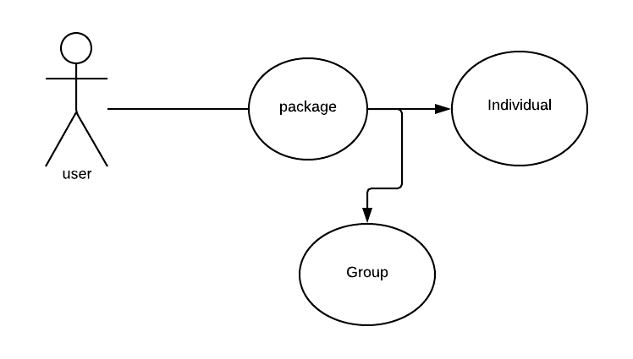

**Use case diagram detail:**

|  |  |
| --- | --- |
| Use Case ID | UC#04 |
| Use Case Name | individual or Group Package |
| Description | Store the individual or group package in database |
| Primary Actor | User |
| Secondary Actor | Admin |
| Pre-Condition | Must be login |
| Post-Condition | none |
| Basic Flow | Actor Action System Action |
|  | Select Individual or Group Return the selection information |
| Alternate Flow | none |

Table 04

**3.5. Add Individual or Group Custom Package**

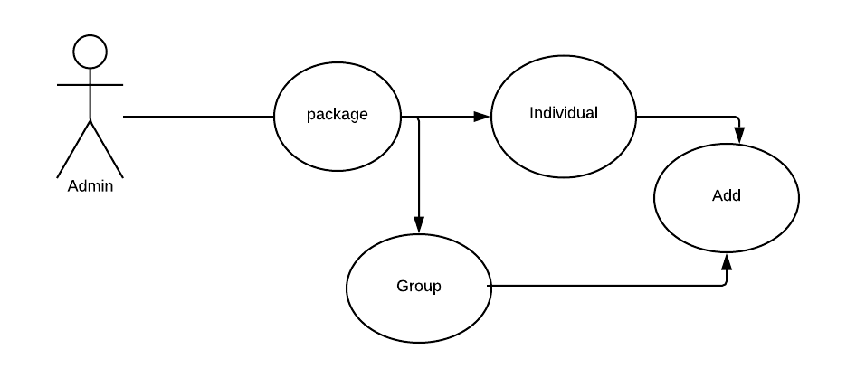

**Use case diagram detail:**

|  |  |
| --- | --- |
| Use Case ID | UC#05 |
| Use Case Name | Add individual or Group Package |
| Description | Save the individual or Group Package in database |
| Primary Actor | User |
| Secondary Actor | Admin |
| Pre-Condition | Must be login |
| Post-Condition | none |
| Basic Flow | Actor Action System Action |
|  | Add Custom Package Store the Package |
| Alternate Flow | none |

Table 05

**3.6. Update Individual or Group Package**

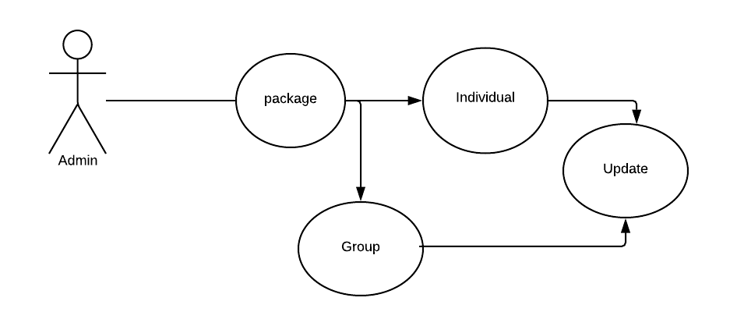

**Use case diagram detail:**

|  |  |
| --- | --- |
| Use Case ID | UC#06 |
| Use Case Name | Update individual or Group packages |
| Description | Edit the individual or Group packages in database |
| Primary Actor | User |
| Secondary Actor | none |
| Pre-Condition | Must be login |
| Post-Condition | none |
| Basic Flow | Actor Action System Action |
|  | Update the information Return and store information |
| Alternate Flow | none |

Table 06

**3.7. Delete Individual or Group Package**

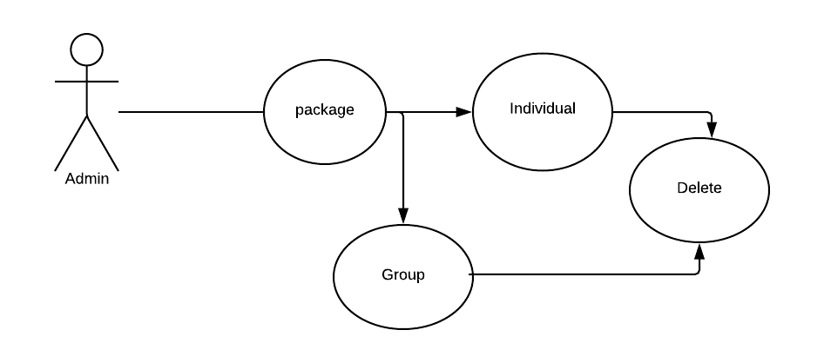

**Use case diagram detail:**

|  |  |
| --- | --- |
| Use Case ID | UC#07 |
| Use Case Name | Delete Individual or Group Package |
| Description | Delete the Individual or Group Package from database |
| Primary Actor | User |
| Secondary Actor | none |
| Pre-Condition | Must be login |
| Post-Condition | none |
| Basic Flow | Actor Action System Action |
|  | Select and delete delete the Package |
| Alternate Flow |  |

Table 07

**3.8. Flight Information**

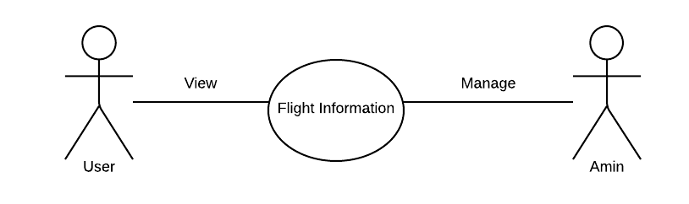

**Use case diagram detail:**

|  |  |
| --- | --- |
| Use Case ID | UC#08 |
| Use Case Name | Flight’s information |
| Description | View the Flight’s |
| Primary Actor | User |
| Secondary Actor | Admin |
| Pre-Condition | Must be login |
| Post-Condition | internet |
| Basic Flow | Actor Action System Action |
|  | Select the Flight Return the selection information |
| Alternate Flow | none |

Table 08

**3.9. Add Flight information**

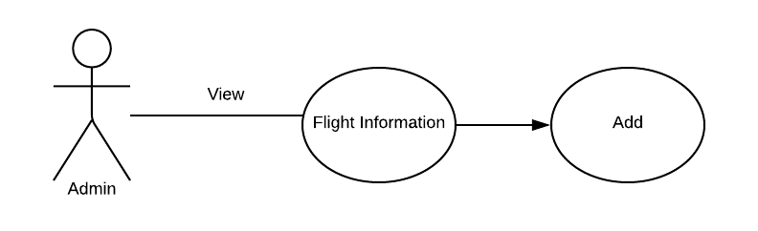

**Use case diagram detail:**

|  |  |
| --- | --- |
| Use Case ID | UC#09 |
| Use Case Name | Add Flight’s information |
| Description | Add new flight’s information |
| Primary Actor | Admin |
| Secondary Actor | None |
| Pre-Condition | Must be login |
| Post-Condition | Internet |
| Basic Flow | Actor Action System Action |
|  | Add new Return the information |
| Alternate Flow | none |

Table 09

**3.10. Update Flight information**

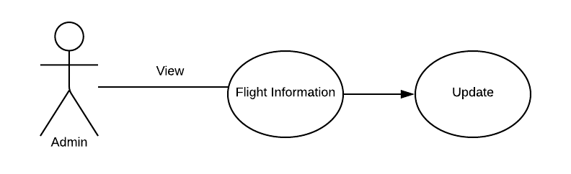

**Use case diagram detail:**

|  |  |
| --- | --- |
| Use Case ID | UC#10 |
| Use Case Name | Update Flight’s information |
| Description | Update the Flight’s information |
| Primary Actor | Admin |
| Secondary Actor | none |
| Pre-Condition | Must be login |
| Post-Condition | Internet |
| Basic Flow | Actor Action System Action |
|  | Select and update Return the selection information |
| Alternate Flow | none |

Table 10

**3.11. Delete flight information**

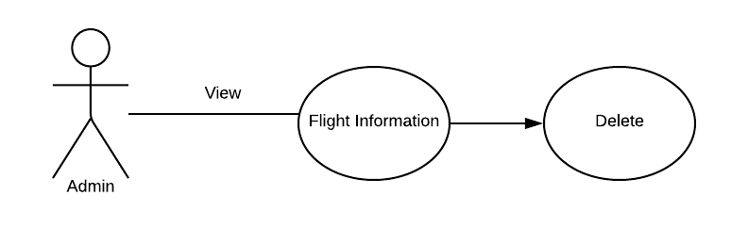

**Use case diagram detail:**

|  |  |
| --- | --- |
| Use Case ID | UC#11 |
| Use Case Name | Delete Flight’s information |
| Description | Delete the flight’s information |
| Primary Actor | User |
| Secondary Actor | None |
| Pre-Condition | Must be login |
| Post-Condition | Internet |
| Basic Flow | Actor Action System Action |
|  | Delete the flight delete the selection information |
| Alternate Flow | none |

Table 11

**3.12. Flight Class**

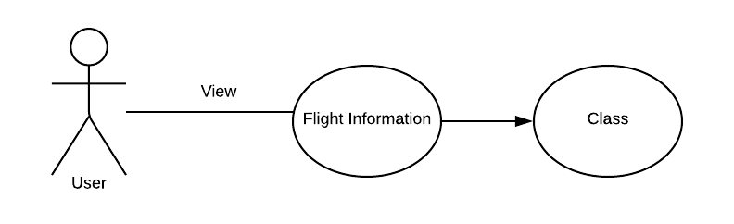

**Use case diagram detail:**

|  |  |
| --- | --- |
| Use Case ID | UC#12 |
| Use Case Name | Flight’s Class |
| Description | Select type of flight class |
| Primary Actor | User |
| Secondary Actor | None |
| Pre-Condition | Must be login |
| Post-Condition | Internet |
| Basic Flow | Actor Action System Action |
|  | Selection type of class Return the Selection information |
| Alternate Flow | none |

Table 12

**3.13. Seat Conformation flight**

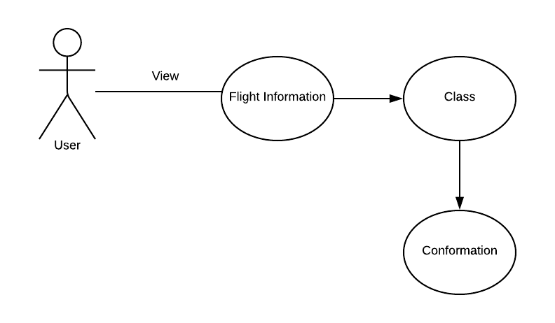

**Use case diagram detail:**

|  |  |
| --- | --- |
| Use Case ID | UC#13 |
| Use Case Name | Flight’s Conformation |
| Description | Click the save button |
| Primary Actor | User |
| Secondary Actor | None |
| Pre-Condition | Must be login |
| Post-Condition | Internet |
| Basic Flow | Actor Action System Action |
|  | Book the Seat Conformation the booking with  popup message |
| Alternate Flow | none |

Table 13

**3.14. Insurance**

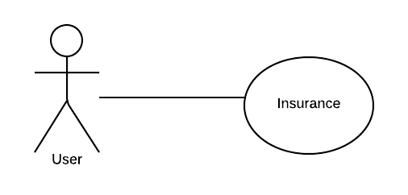

**Use case diagram detail:**

|  |  |
| --- | --- |
| Use Case ID | UC#14 |
| Use Case Name | Insurance |
| Description | If you want to avail the insurance then mark the insurance checkbox |
| Primary Actor | User |
| Secondary Actor | None |
| Pre-Condition | Must be login |
| Post-Condition | Internet |
| Basic Flow | Actor Action System Action |
|  | Mark the checkbox Show available options regarding  insurance |
| Alternate Flow | none |

Table 14

**3.15. Travel Insurance**

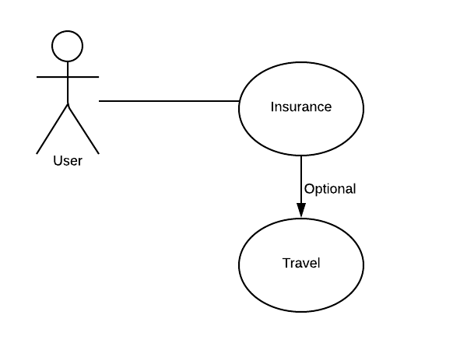

**Use case diagram detail:**

|  |  |
| --- | --- |
| Use Case ID | UC#15 |
| Use Case Name | Travel Insurance |
| Description | If you want to avail the travel insurance then mark the insurance checkbox |
| Primary Actor | User |
| Secondary Actor | None |
| Pre-Condition | Must be login |
| Post-Condition | Internet |
| Basic Flow | Actor Action System Action |
|  | Mark the travel insurance checkbox Show available options regarding  insurance |
| Alternate Flow | none |

Table 15

**3.16. Flight Insurance**

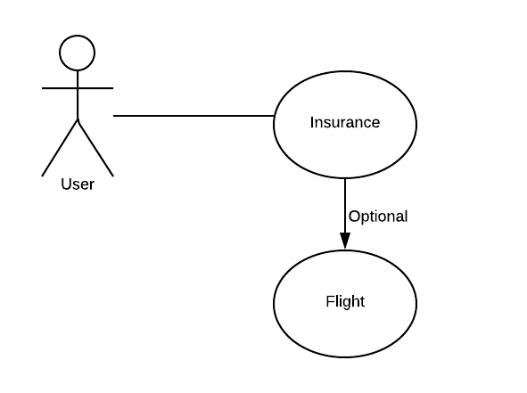

**Use case diagram detail:**

|  |  |
| --- | --- |
| Use Case ID | UC#16 |
| Use Case Name | Flight Insurance |
| Description | If you want to avail the flight insurance then mark the insurance checkbox |
| Primary Actor | User |
| Secondary Actor | None |
| Pre-Condition | Must be login |
| Post-Condition | Internet |
| Basic Flow | Actor Action System Action |
|  | Mark the flight insurance checkbox Show available options regarding  insurance |
| Alternate Flow | none |

Table 16

**3.17. User / Admin Logout**

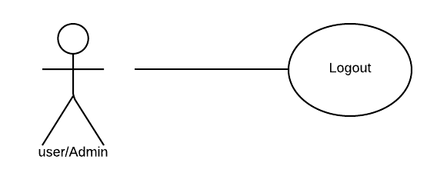

**Use case diagram detail:**

|  |  |
| --- | --- |
| Use Case ID | UC#17 |
| Use Case Name | Logout |
| Description | Logout from the Web Portal |
| Primary Actor | User/Admin |
| Secondary Actor | none |
| Pre-Condition | Must be login |
| Post-Condition | none |
| Basic Flow | Actor Action System Action |
|  | Click Logout Logout the user / Admin |
| Alternate Flow | none |

Table 17

**3.18. ADD HOTEL INFORMATION**

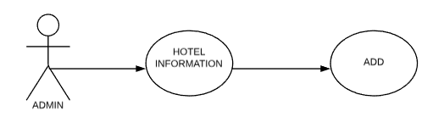

**Use case diagram detail:**

|  |  |
| --- | --- |
| Use Case ID | UC#18 |
| Use Case Name | Add Hotel’s information |
| Description | Add new hotel’s information in database |
| Primary Actor | Admin |
| Secondary Actor | None |
| Pre-Condition | Must be login |
| Post-Condition | Internet |
| Basic Flow | Actor Action System Action |
|  | Add new Return the information |
| Alternate Flow | none |

**3.19. DELETE HOTEL INFORMATION**

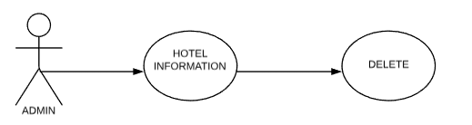

**Use case diagram detail:**

|  |  |
| --- | --- |
| Use Case ID | UC#19 |
| Use Case Name | Delete Hotel’s information |
| Description | Delete the hotel’s information from the database |
| Primary Actor | User |
| Secondary Actor | None |
| Pre-Condition | Must be login |
| Post-Condition | Internet |
| Basic Flow | Actor Action System Action |
|  | Delete the hotel delete the selection information |
| Alternate Flow | none |

**3.20. UPDATE HOTEL INFORMATION**

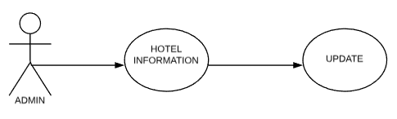

**Use case diagram detail:**

|  |  |
| --- | --- |
| Use Case ID | UC#20 |
| Use Case Name | Update Hotel’s information |
| Description | Update the Update Hotel’s information from database |
| Primary Actor | Admin |
| Secondary Actor | None |
| Pre-Condition | Must be login |
| Post-Condition | Internet |
| Basic Flow | Actor Action System Action |
|  | Select and update Return the selection information |
| Alternate Flow | None |

**3.21. ADD FLIGHT INFORMATION**

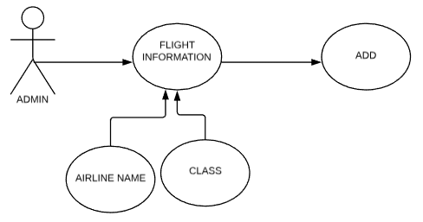

**Use case diagram detail:**

|  |  |
| --- | --- |
| Use Case ID | UC#21 |
| Use Case Name | Add Flight information |
| Description | Add Flight information to database |
| Primary Actor | Admin |
| Secondary Actor | None |
| Pre-Condition | Must be login |
| Post-Condition | Internet |
| Basic Flow | Actor Action System Action |
|  | Add New Add selection information |
| Alternate Flow | None |

**3.22. DELETE FLIGHT INFORMATION**

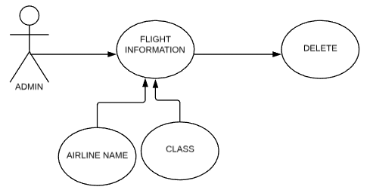

**Use case diagram detail:**

|  |  |
| --- | --- |
| Use Case ID | UC#22 |
| Use Case Name | Add Flight information |
| Description | Delete Flight information from database |
| Primary Actor | Admin |
| Secondary Actor | None |
| Pre-Condition | Must be login |
| Post-Condition | Internet |
| Basic Flow | Actor Action System Action |
|  | Select and delete Delete the selection information |
| Alternate Flow | None |

**3.23. UPDATE FLIGHT INFORMATION**

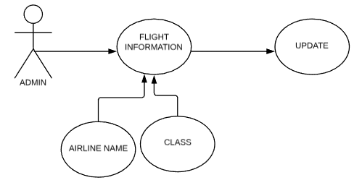

**Use case diagram detail:**

|  |  |
| --- | --- |
| Use Case ID | UC#23 |
| Use Case Name | Update Flight information |
| Description | Update Flight information from database |
| Primary Actor | Admin |
| Secondary Actor | None |
| Pre-Condition | Must be login |
| Post-Condition | Internet |
| Basic Flow | Actor Action System Action |
|  | Select and update Return the selection information |
| Alternate Flow | None |

**3.24. ADD RENT A CAR WITH DRIVER INFORMATION**

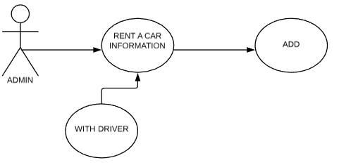

**Use case diagram detail:**

|  |  |
| --- | --- |
| Use Case ID | UC#24 |
| Use Case Name | Add Rent a car with driver information |
| Description | Add Rent a car with driver information to database |
| Primary Actor | Admin |
| Secondary Actor | None |
| Pre-Condition | Must be login |
| Post-Condition | Internet |
| Basic Flow | Actor Action System Action |
|  | Add new ADD information |
| Alternate Flow | None |

**3.25. DELETE RENT A CAR WITH DRIVER INFORMATION**

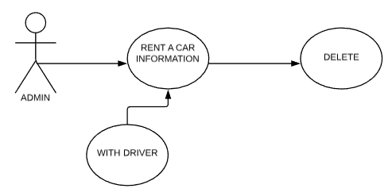

**Use case diagram detail:**

|  |  |
| --- | --- |
| Use Case ID | UC#25 |
| Use Case Name | Delete Rent a car with driver information |
| Description | Delete Rent a car with driver information from database |
| Primary Actor | Admin |
| Secondary Actor | None |
| Pre-Condition | Must be login |
| Post-Condition | Internet |
| Basic Flow | Actor Action System Action |
|  | Select and delete Delete the selection information |
| Alternate Flow | None |

**3.26. UPDATE RENT A CAR WITH DRIVER INFORMATION**

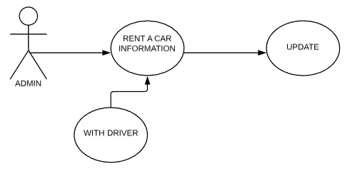

**Use case diagram detail:**

|  |  |
| --- | --- |
| Use Case ID | UC#26 |
| Use Case Name | Update Rent a car with driver information |
| Description | Update Rent a car with driver information from database |
| Primary Actor | Admin |
| Secondary Actor | None |
| Pre-Condition | Must be login |
| Post-Condition | Internet |
| Basic Flow | Actor Action System Action |
|  | Select and update Return the selection information |
| Alternate Flow | None |

**3.27. ADD RENT A CAR WITHOUT DRIVER**

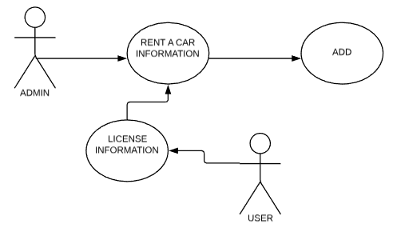

**Use case diagram detail:**

|  |  |
| --- | --- |
| Use Case ID | UC#27 |
| Use Case Name | Add Rent a car self-drive information |
| Description | Add Rent a car self-drive information to database |
| Primary Actor | Admin |
| Secondary Actor | User |
| Pre-Condition | Must be login |
| Post-Condition | Internet |
| Basic Flow | Actor Action System Action |
|  | Add new Add information |
| Alternate Flow | None |

**3.28. DELETE RENT A CAR WITHOUT DRIVER**

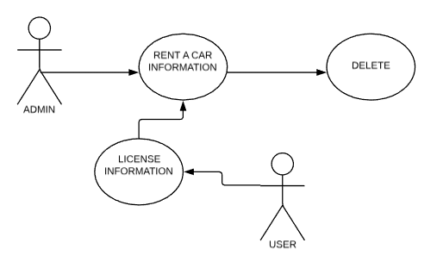

**Use case diagram detail:**

|  |  |
| --- | --- |
| Use Case ID | UC#28 |
| Use Case Name | Delete Rent a car self-drive information |
| Description | Delete Rent a car self-drive information from database |
| Primary Actor | Admin |
| Secondary Actor | User |
| Pre-Condition | Must be login |
| Post-Condition | Internet |
| Basic Flow | Actor Action System Action |
|  | Select and delete Delete the selection information |
| Alternate Flow | None |

**3.29. UPDATE RENT A CAR WITHOUT DRIVER**

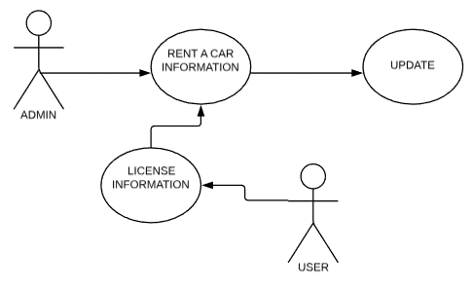

**Use case diagram detail:**

|  |  |
| --- | --- |
| Use Case ID | UC#29 |
| Use Case Name | Update Rent a car self-drive information |
| Description | Update Rent a car self-drive information from database |
| Primary Actor | Admin |
| Secondary Actor | User |
| Pre-Condition | Must be login |
| Post-Condition | Internet |
| Basic Flow | Actor Action System Action |
|  | Select and update Return the selection information |
| Alternate Flow | none |

**3.30. SHOW CUSTOM PACKAGE**

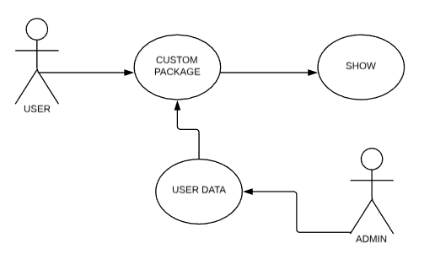

**Use case diagram detail:**

|  |  |
| --- | --- |
| Use Case ID | UC#30 |
| Use Case Name | Show custom package information |
| Description | Show custom package using AI |
| Primary Actor | User |
| Secondary Actor | Admin |
| Pre-Condition | Must be login |
| Post-Condition | Internet |
| Basic Flow | Actor Action System Action |
|  | Show packages Show information |
| Alternate Flow | none |

**Chapter 4: Design**

**4.1. Architecture Diagram**

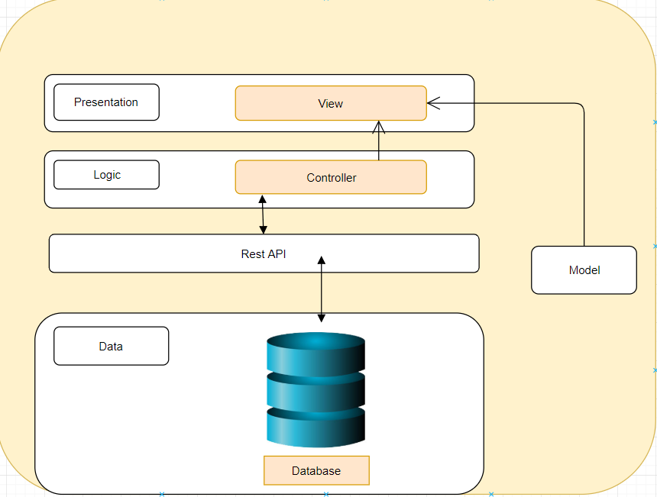

**4.2. ERD with data dictionary**

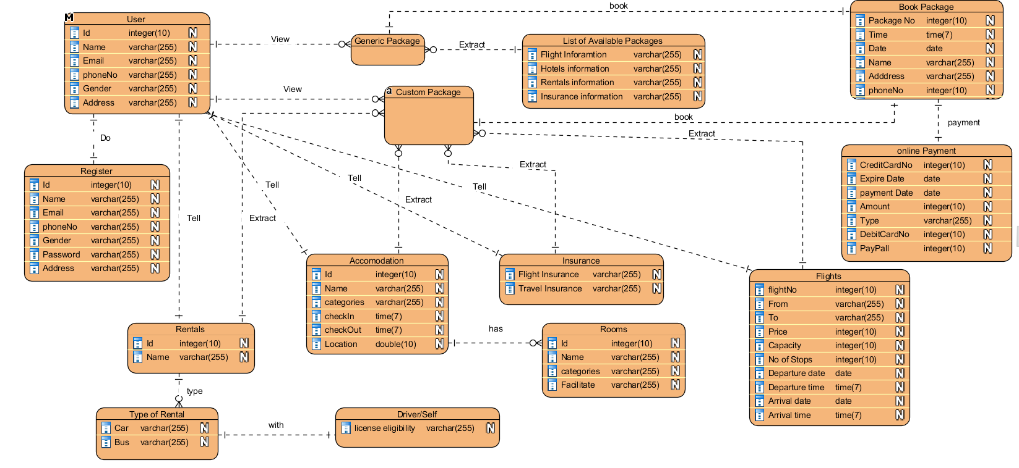

**4.3. Data Flow diagram**

**4.3.1. Level 0**

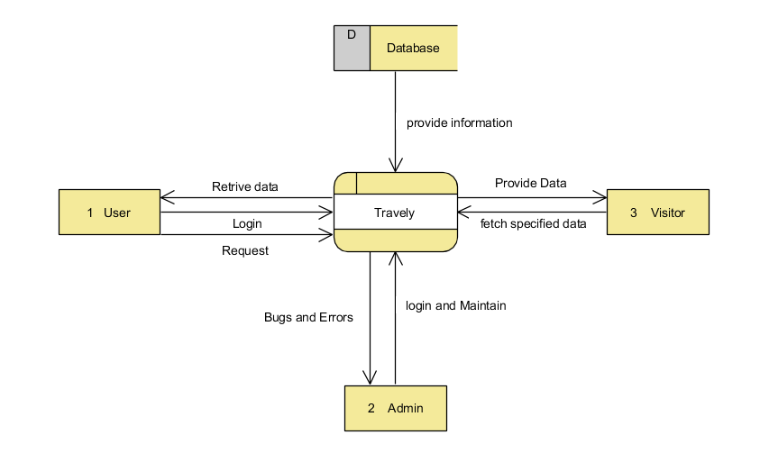

**4.3.2. Level 1**

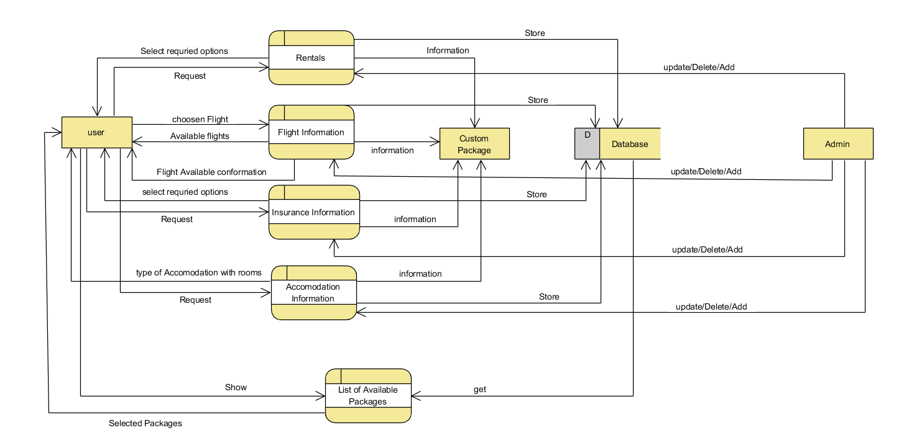

**4.4. Class Diagram**

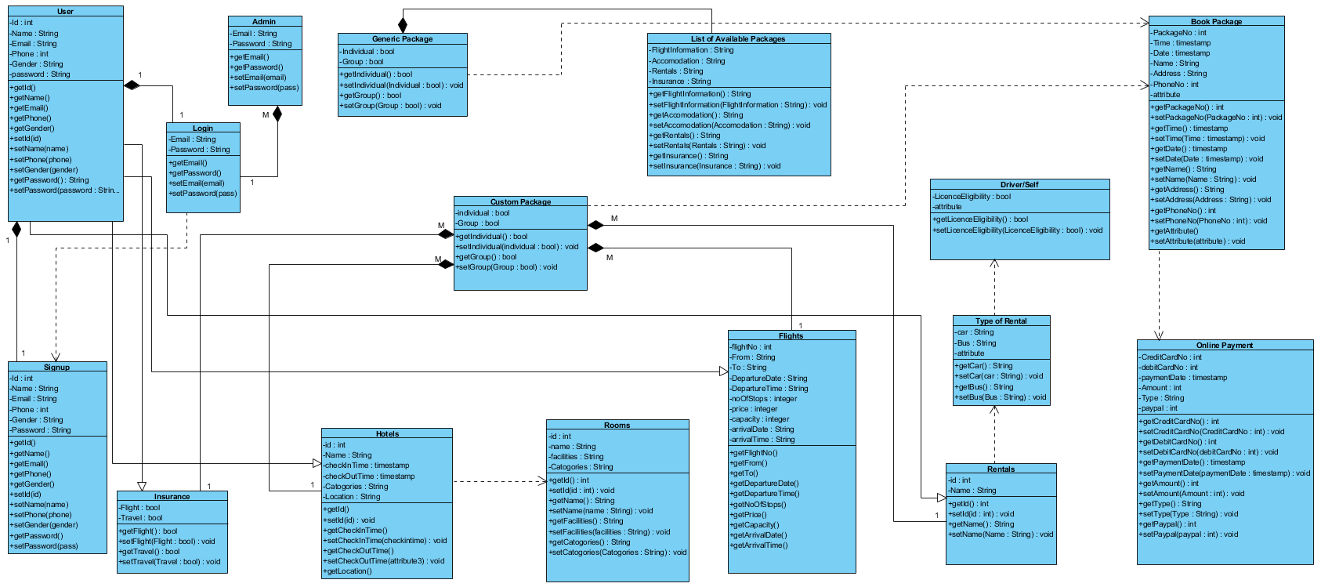

**4.5. Activity Diagram**

**4.5.1. Register**

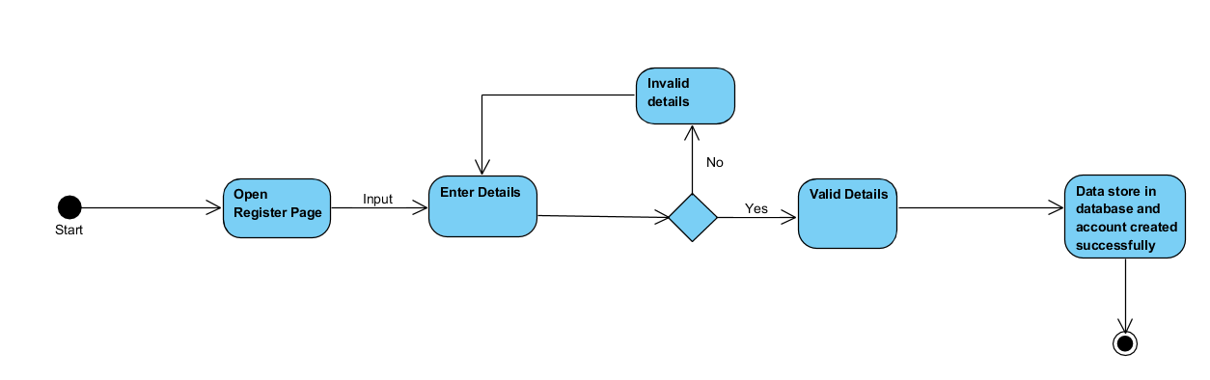

**4.5.2. Login**

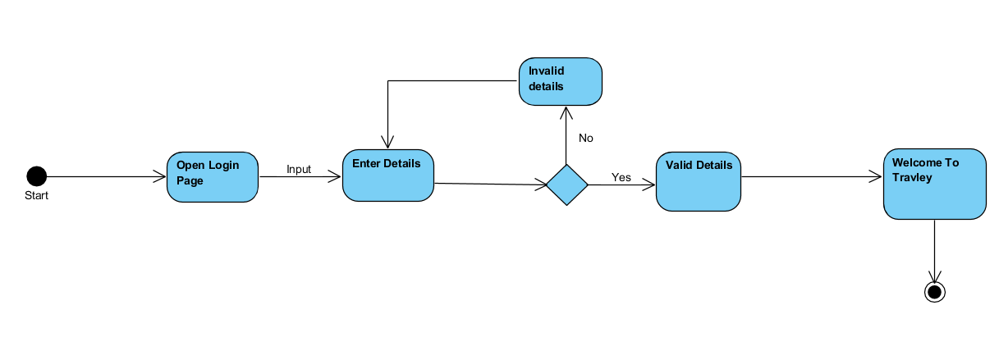**4.5.3. Current Location**

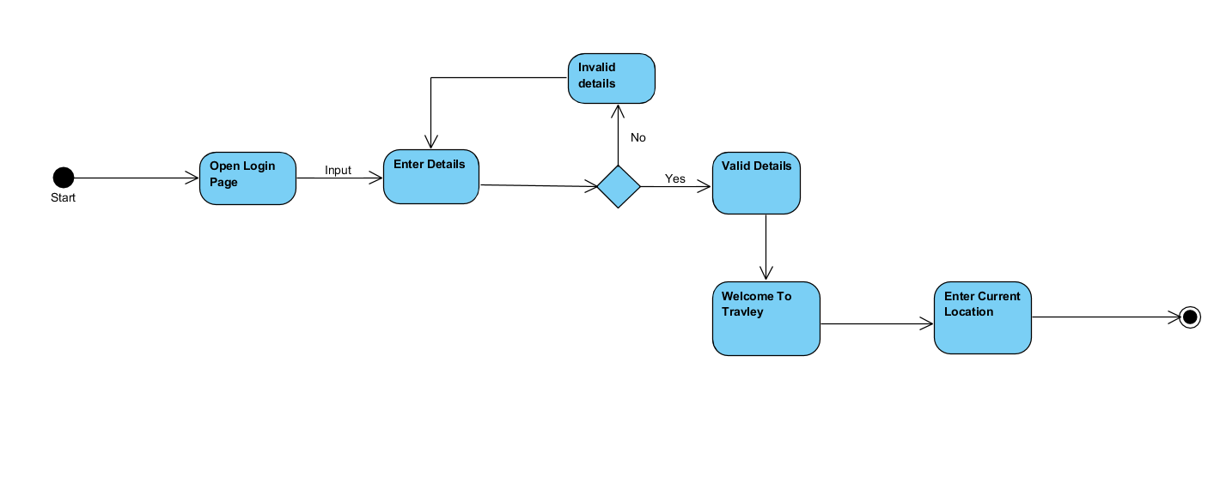

**4.5.4. Destination Location**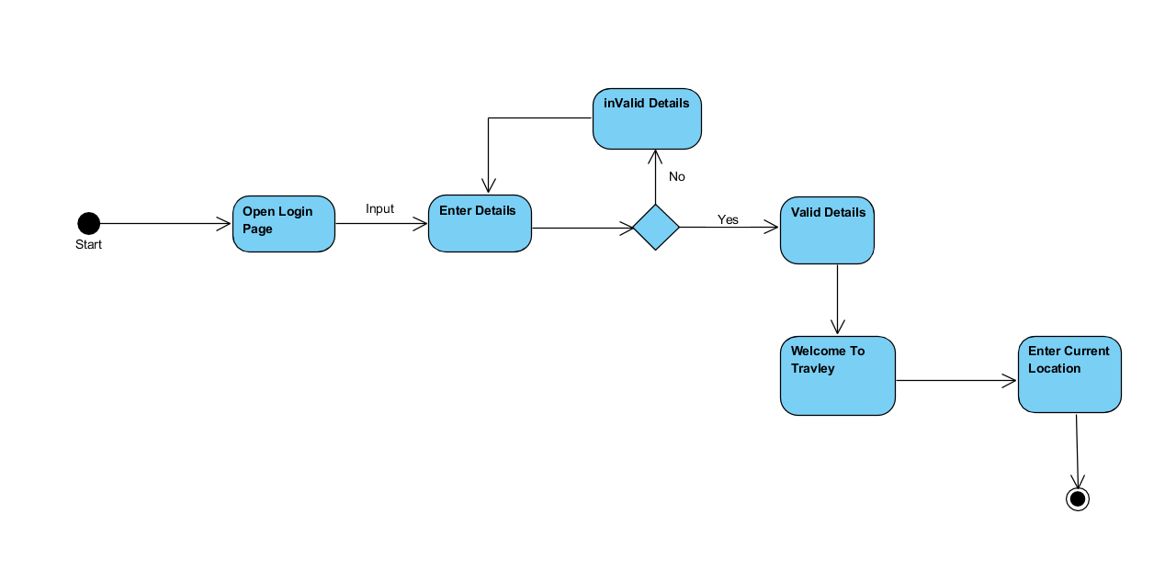

**4.5.5. Check in**

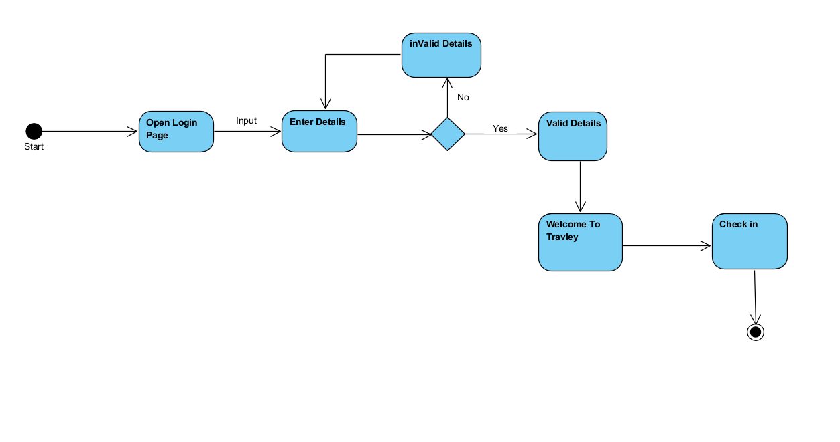

**4.5.6. Check out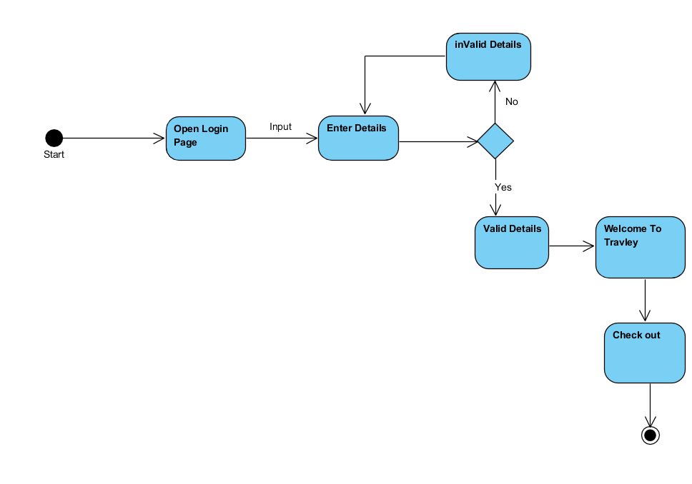4.5.7. Number of Person**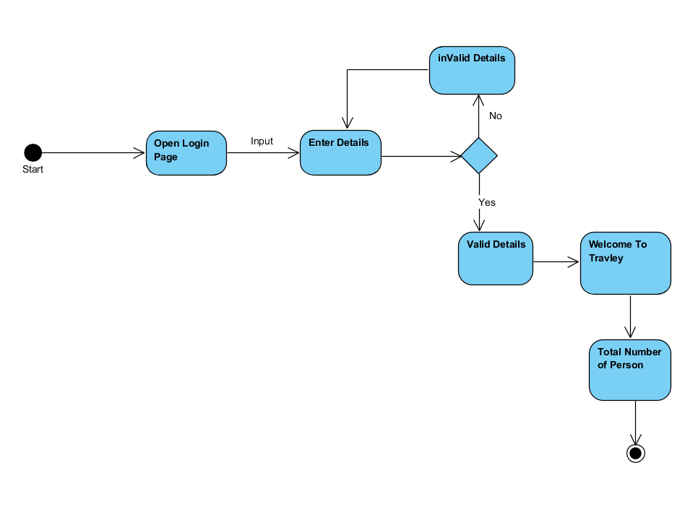

**4.5.8. Select Package**

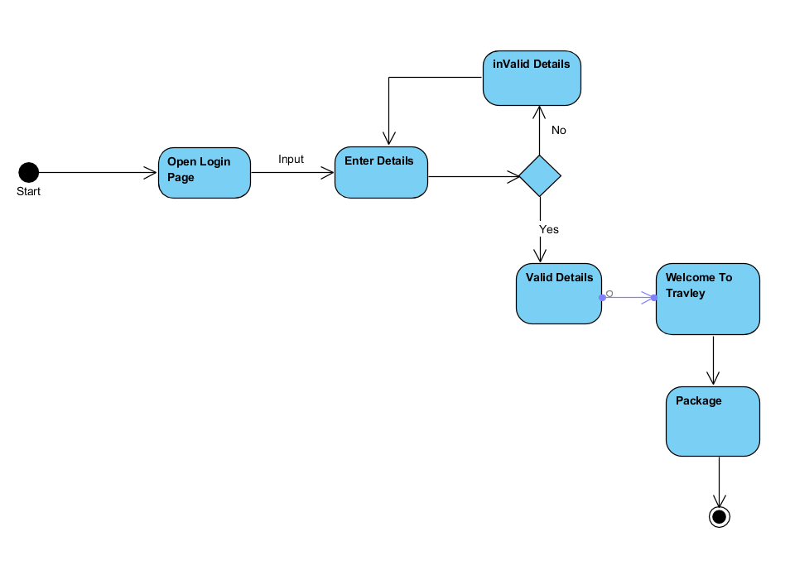

**4.5.9. Generic Package**

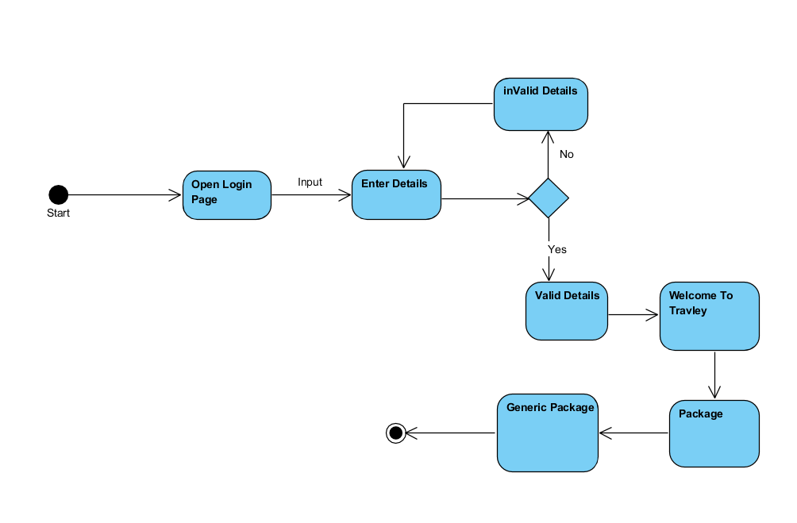**4.5.10. Custom Package**

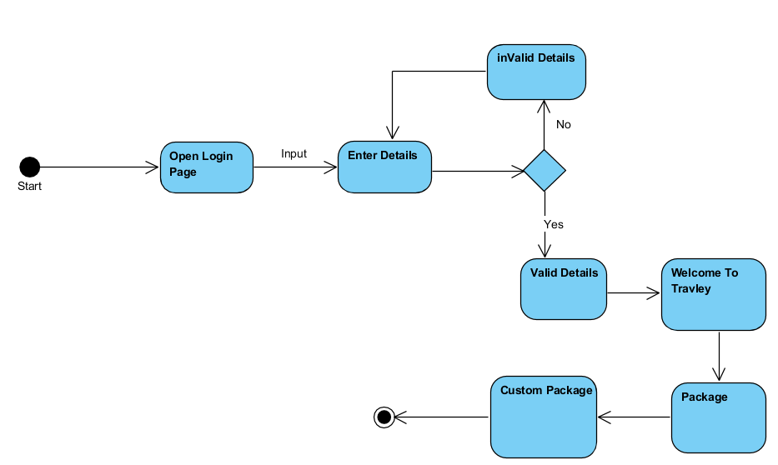

**4.5.11. Select Airline**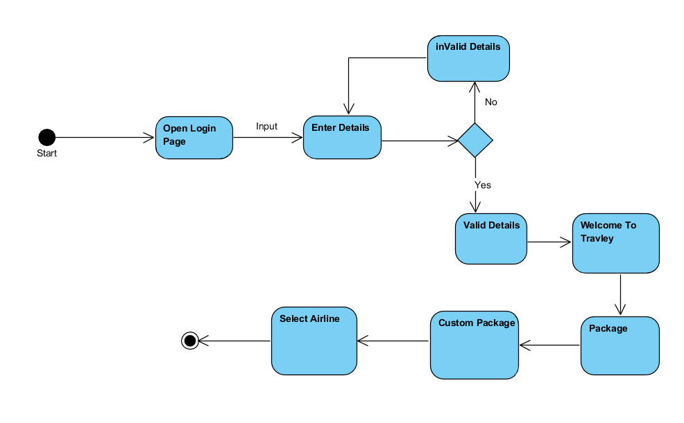

**4.5.12. Ticket Class**

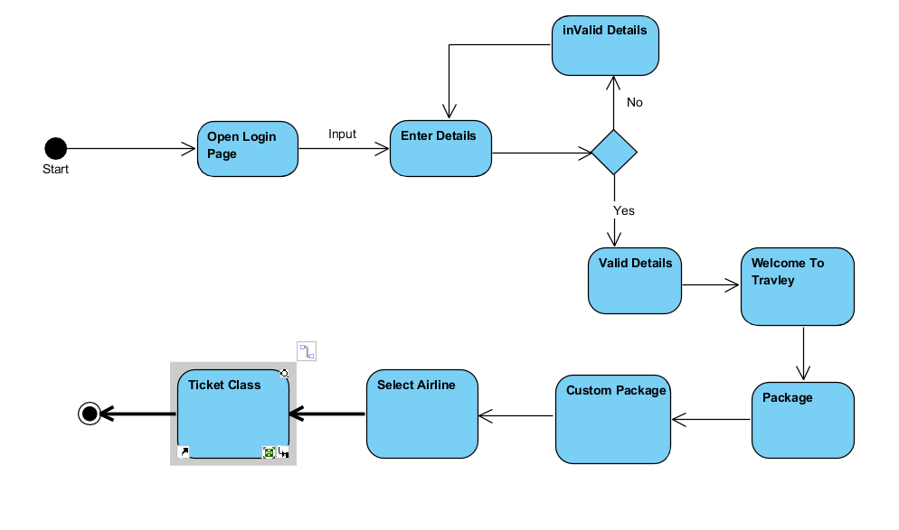

**4.5.13. Select Hotel**

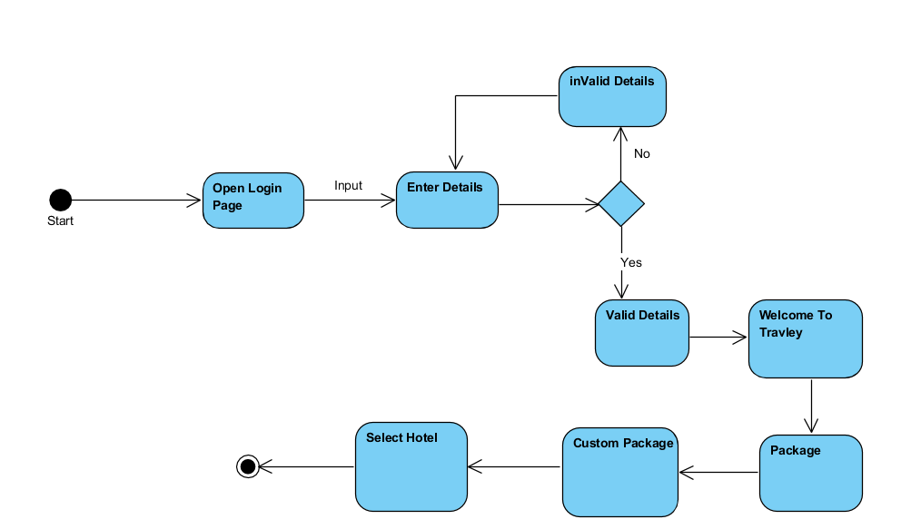

**4.5.14. Number of Rooms**

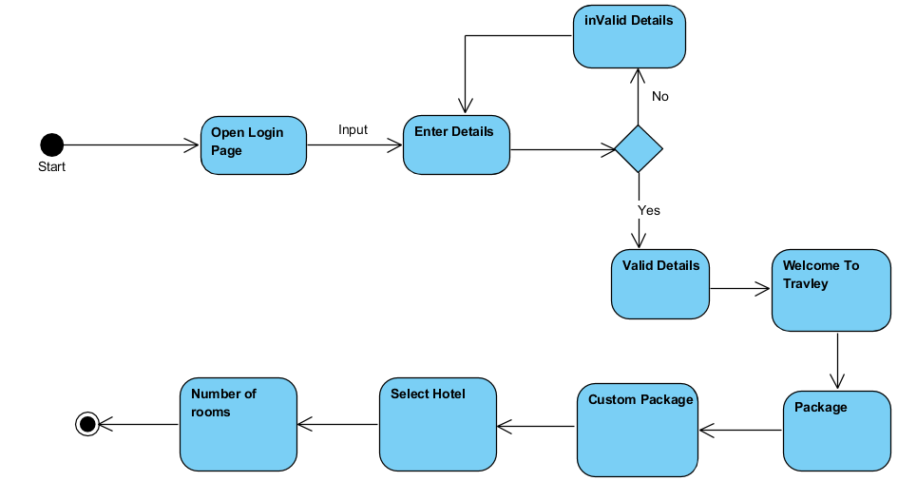

**4.5.15. Room Type**

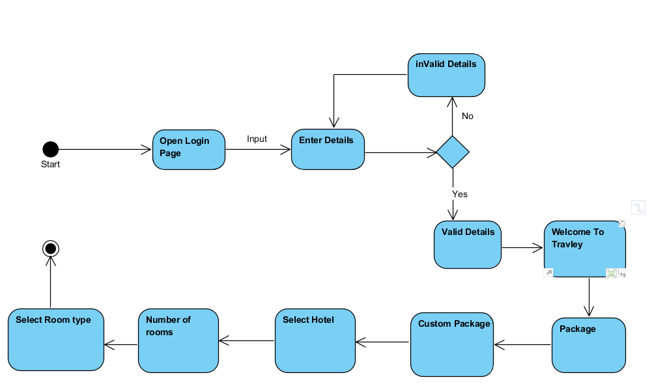

**4.5.16. Rentals**

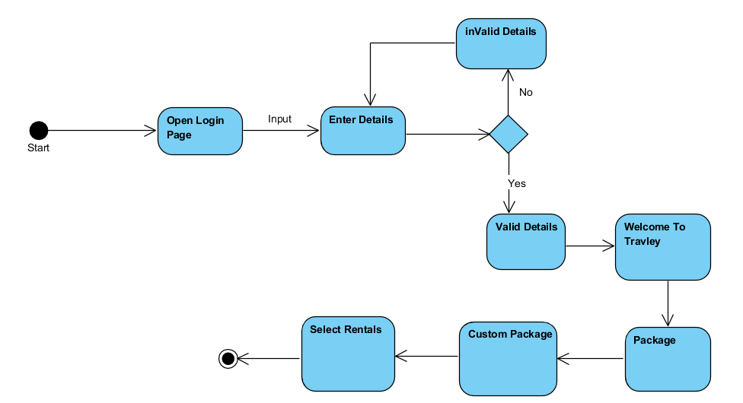

**4.5.17. Type of Vehicle**

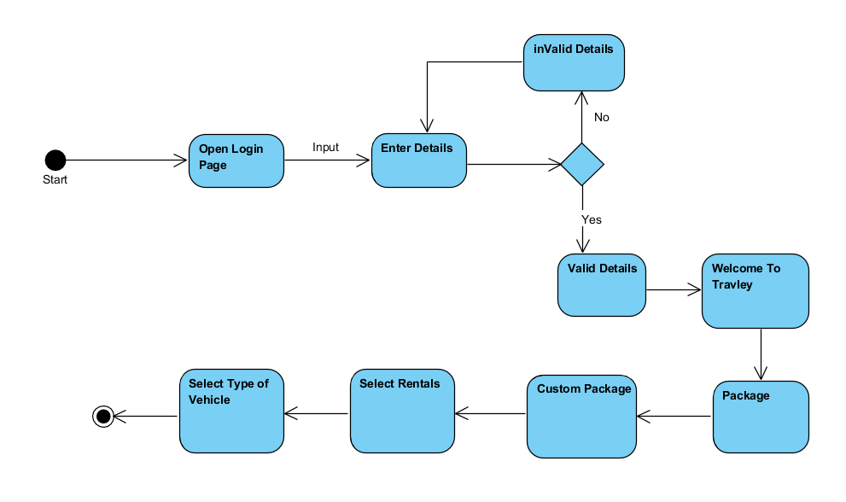

**4.5.18. Insurance**

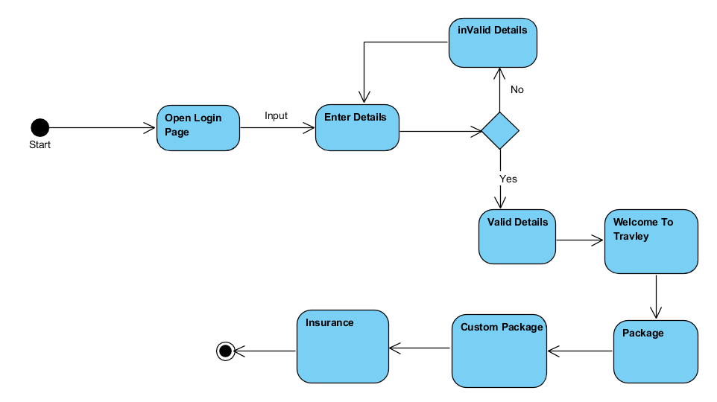

**4.5.18. Type of Insurance**

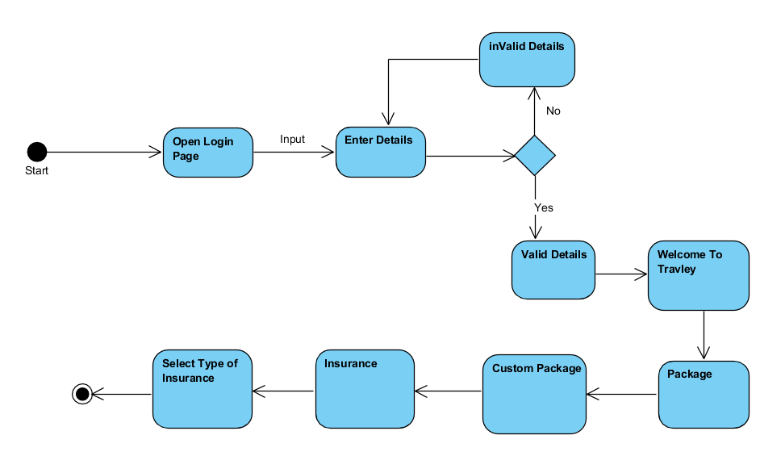

**4.5.19. Generic Package**

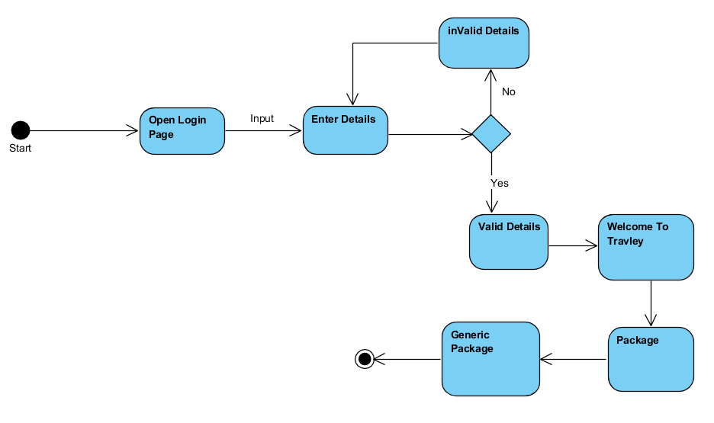

**4.5.20. Available Packages**

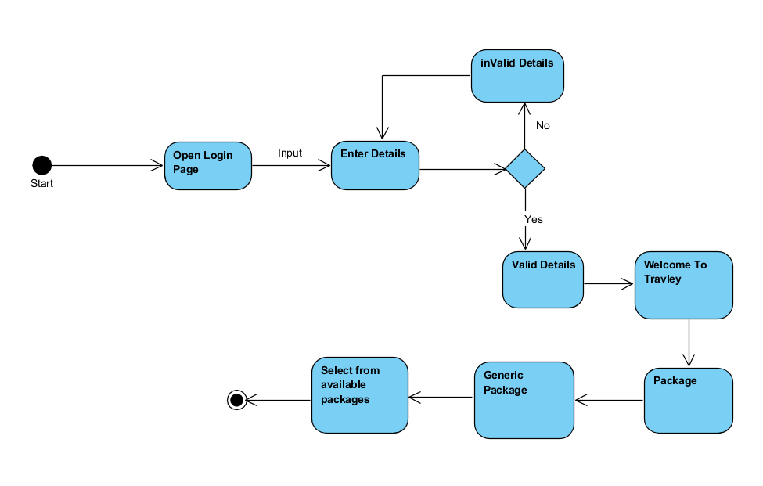

**4.5.21. Logout**

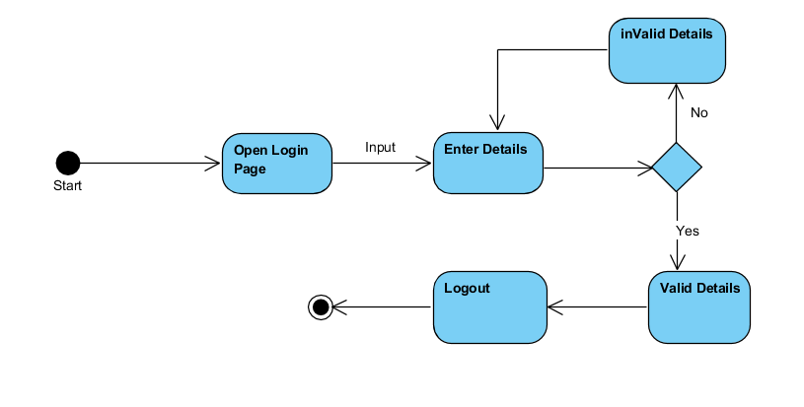

**4.6. Sequence Diagram**

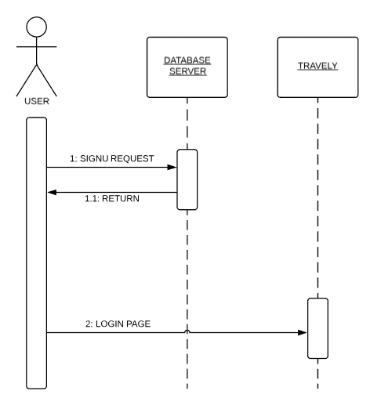

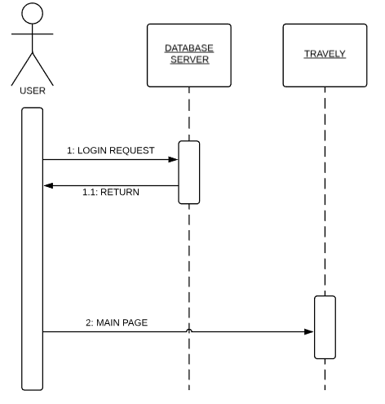

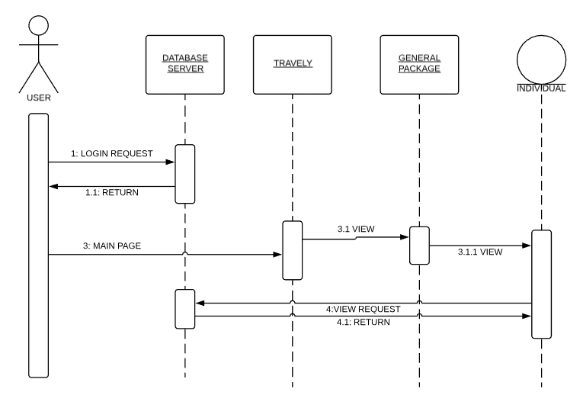

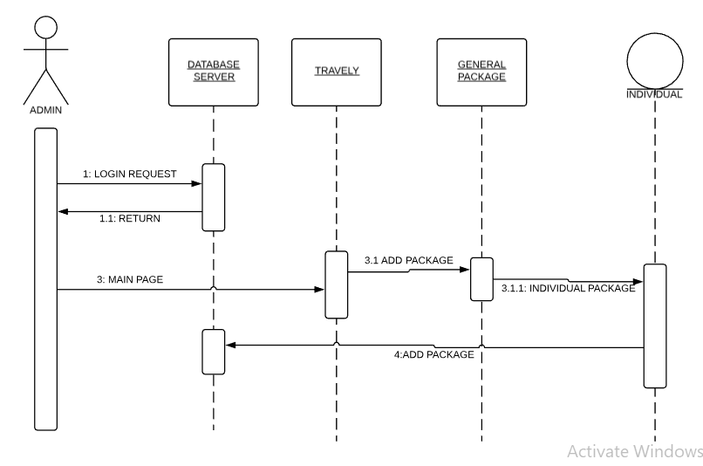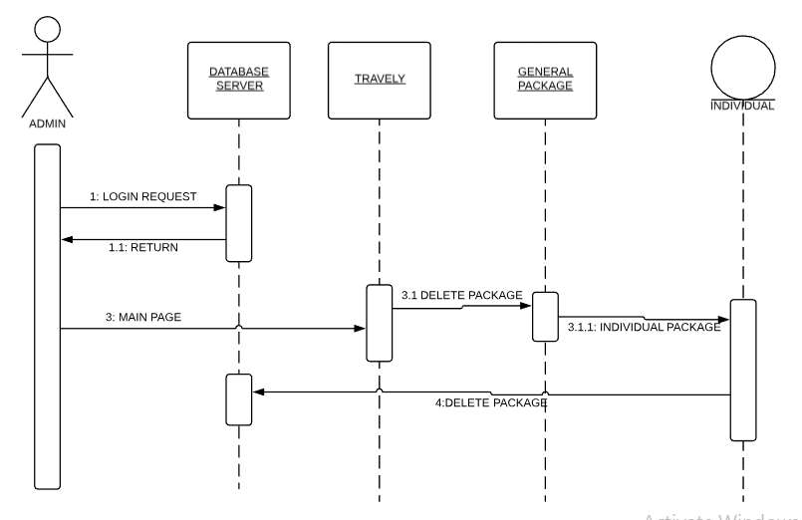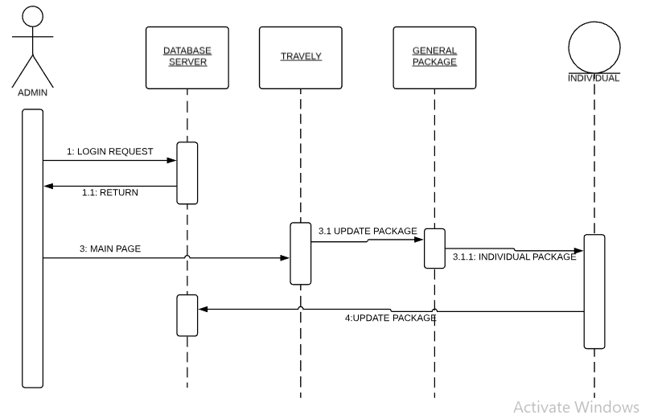

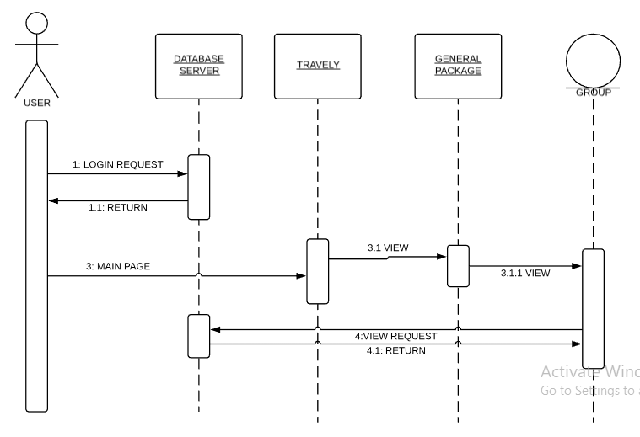

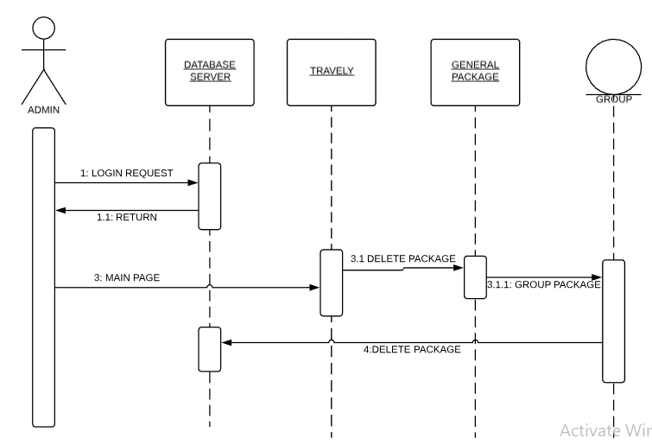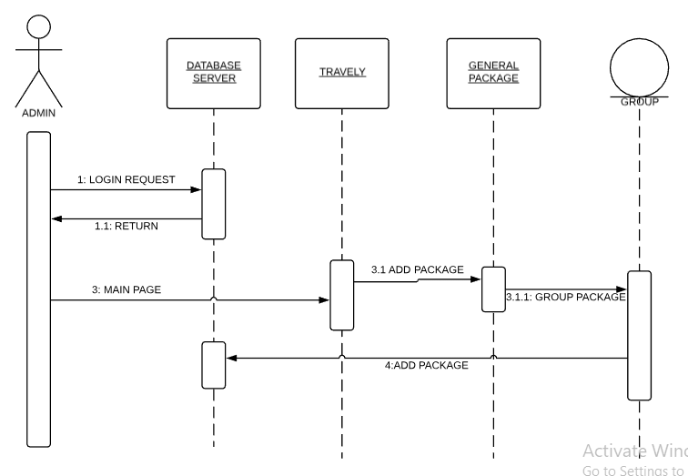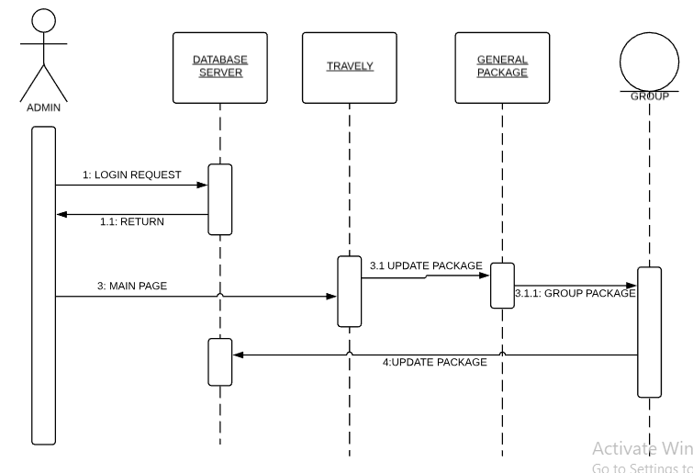

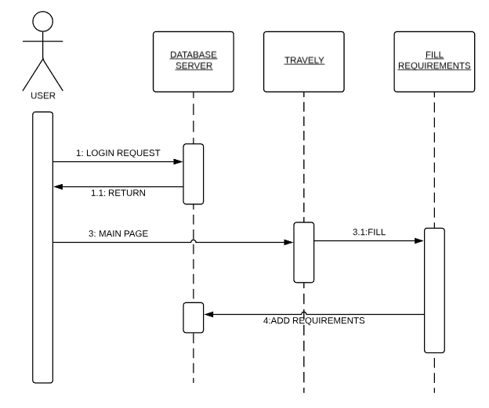

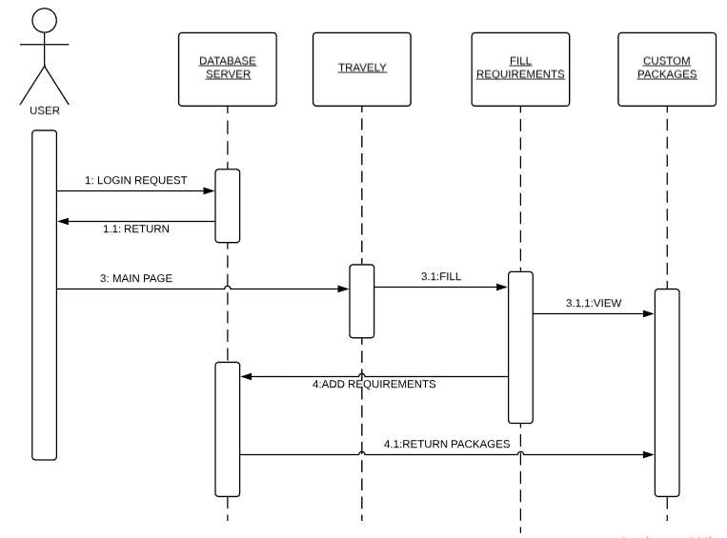

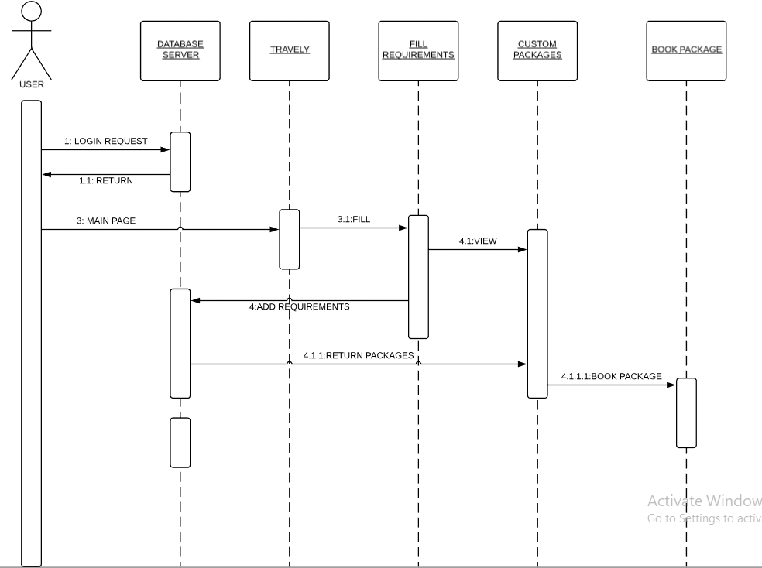

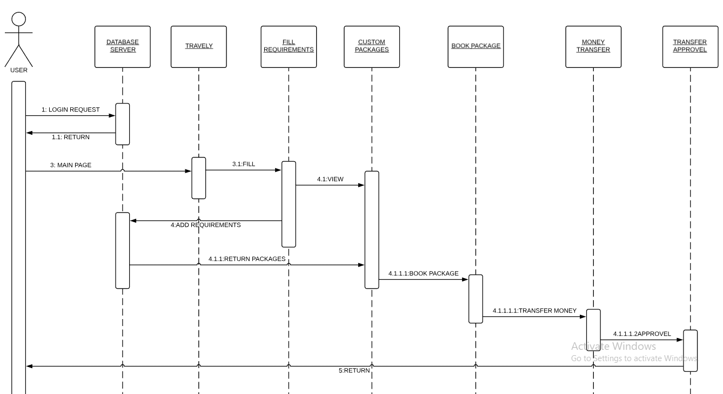

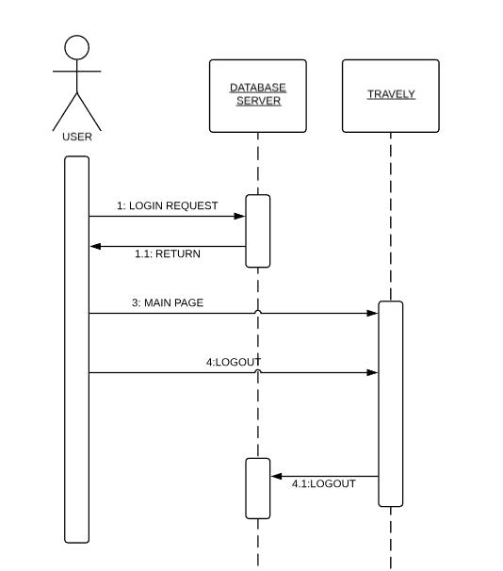

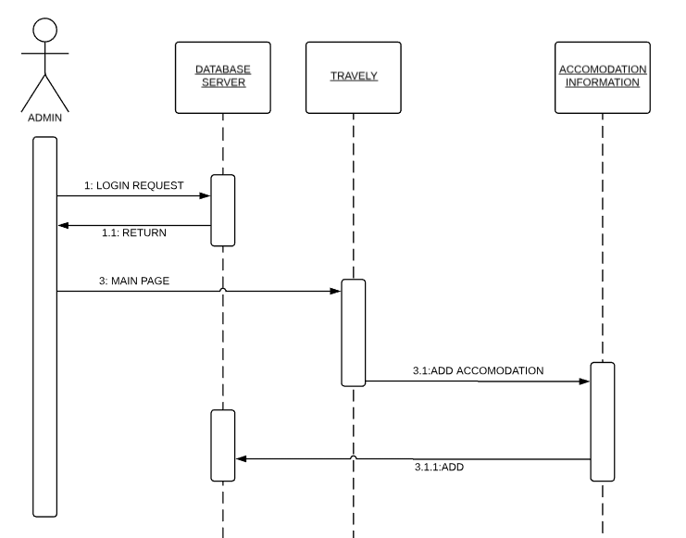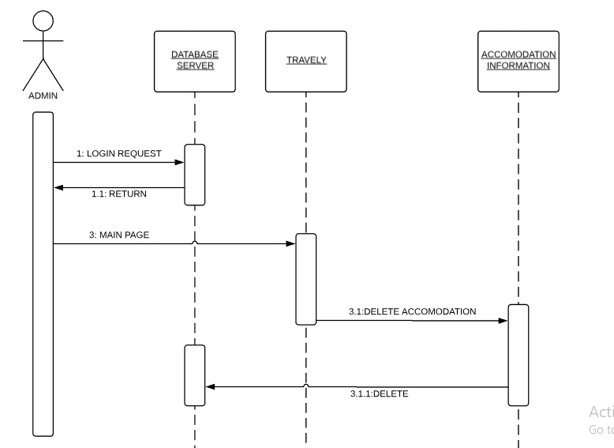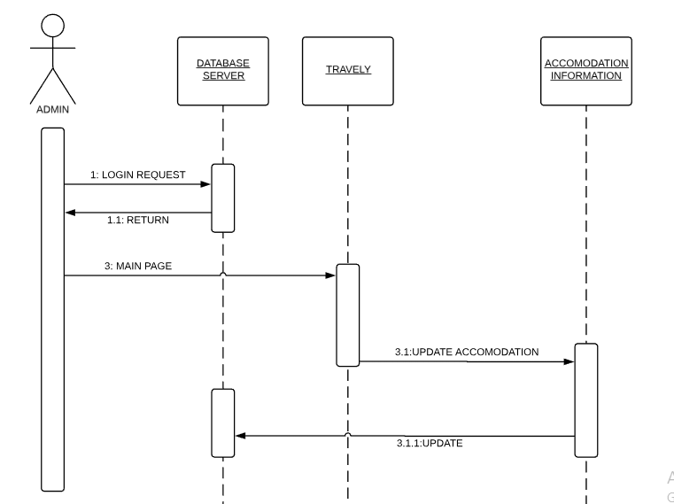

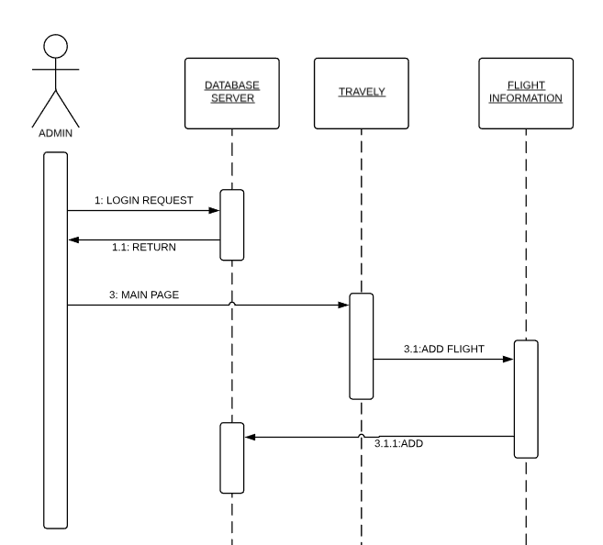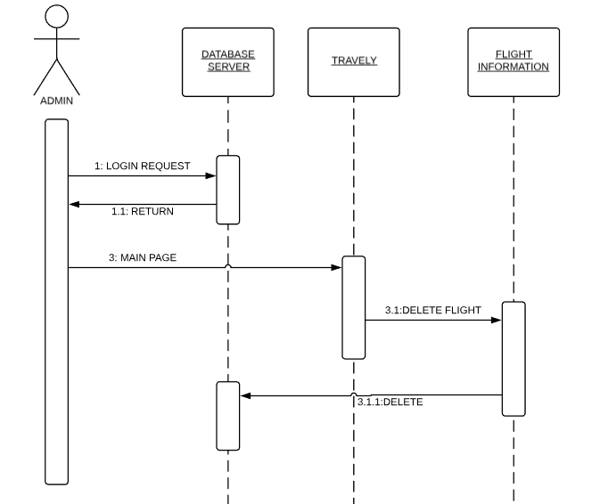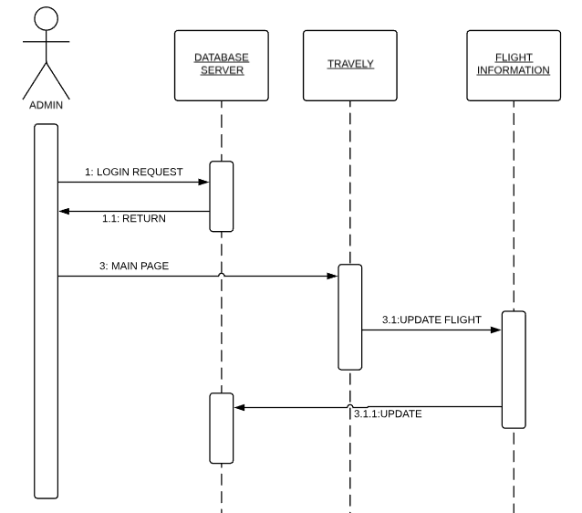

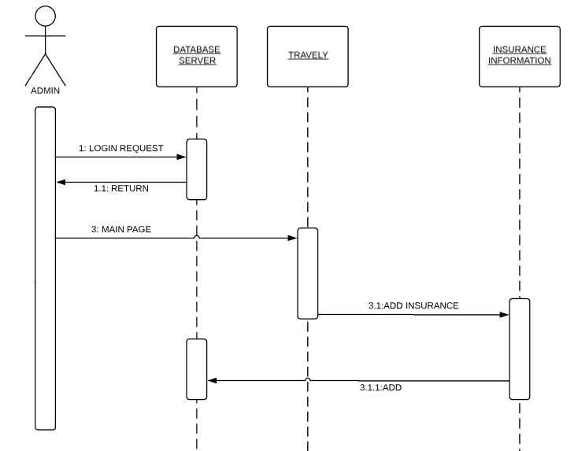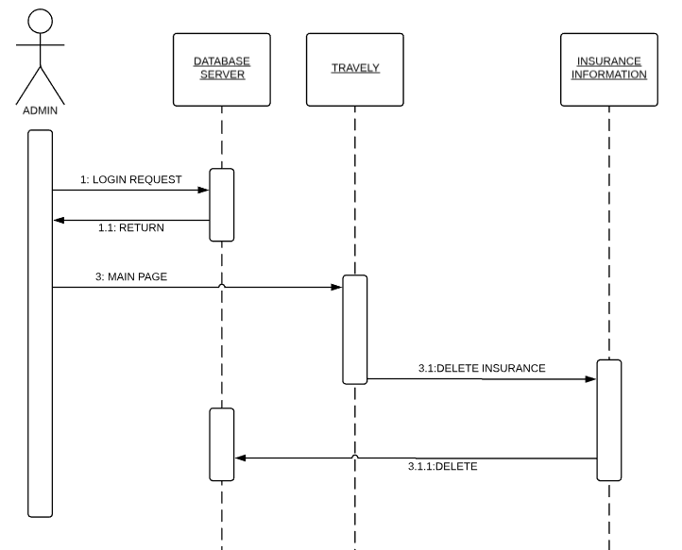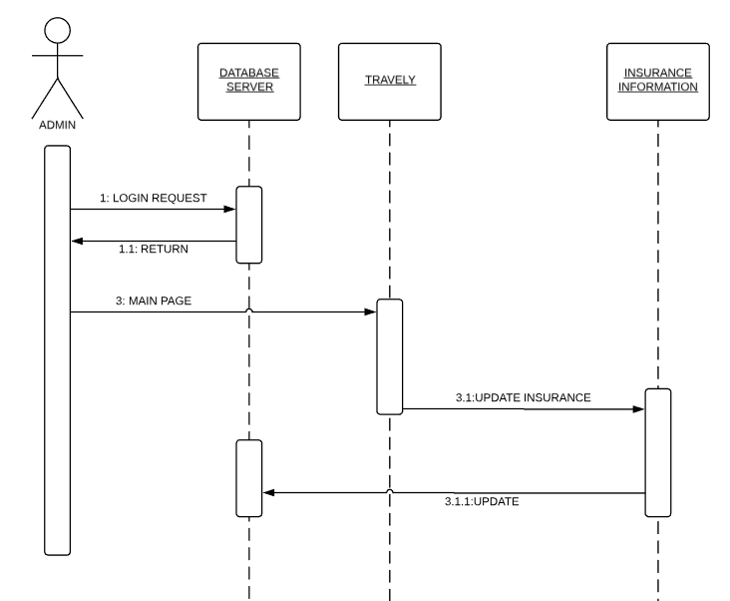

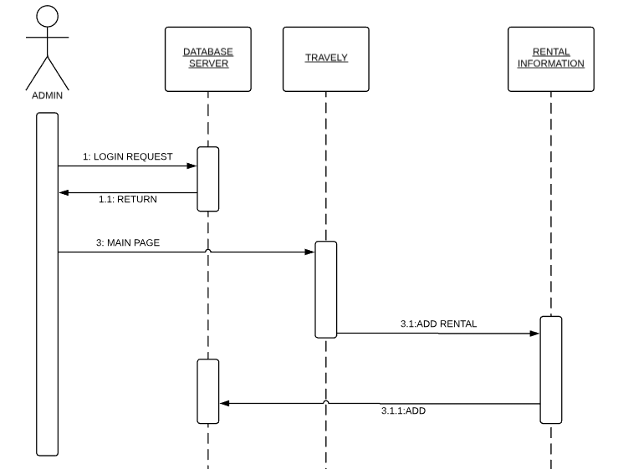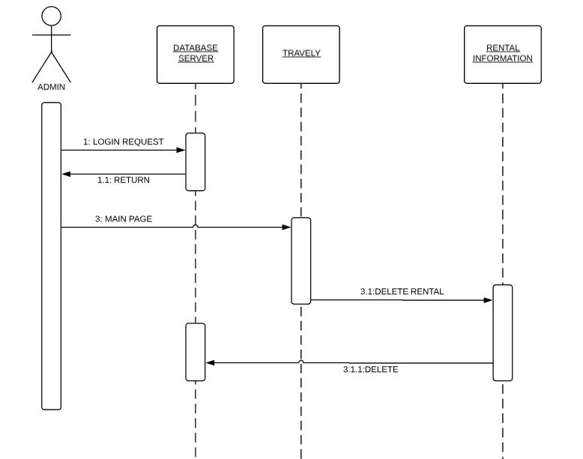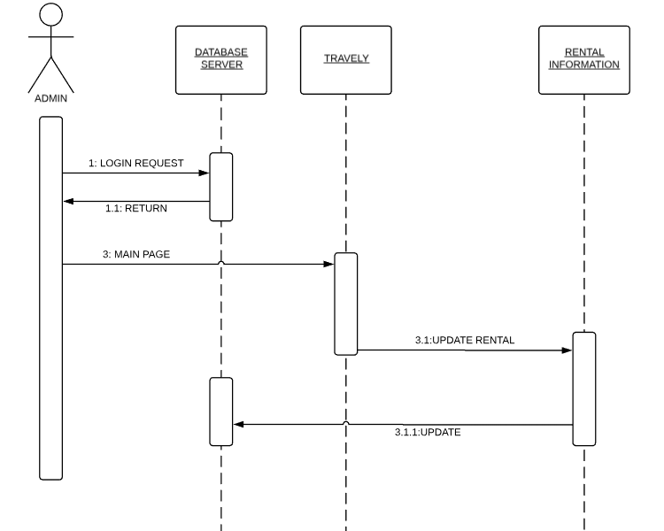

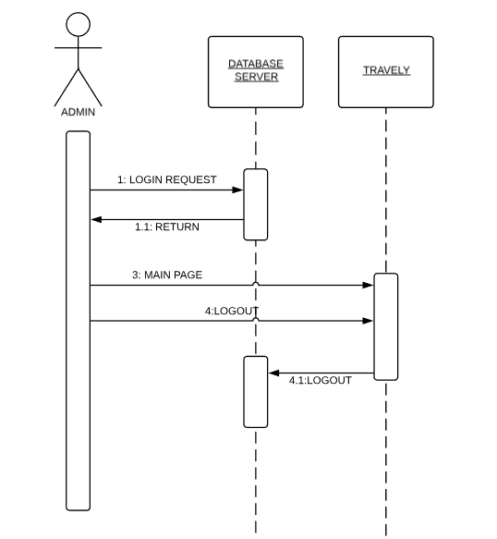

**4.7. Collaboration Diagram**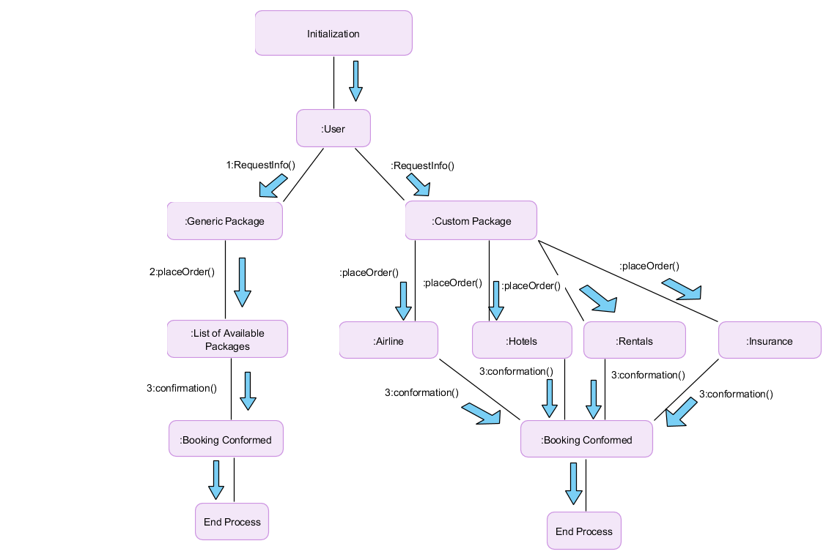

**4.8. State Transition Diagram**

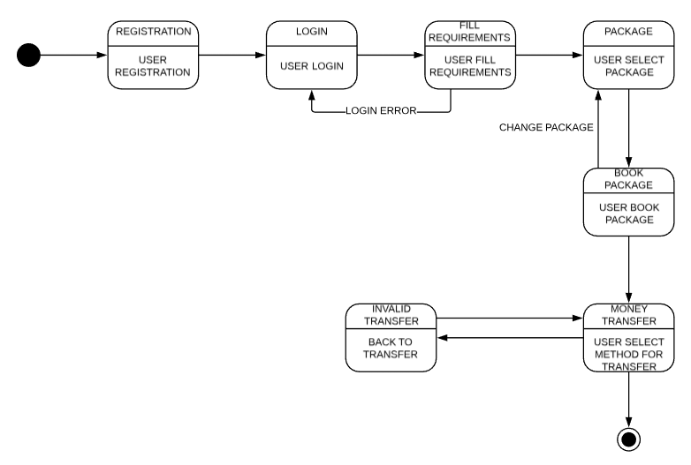

**4.9. Component Diagram**

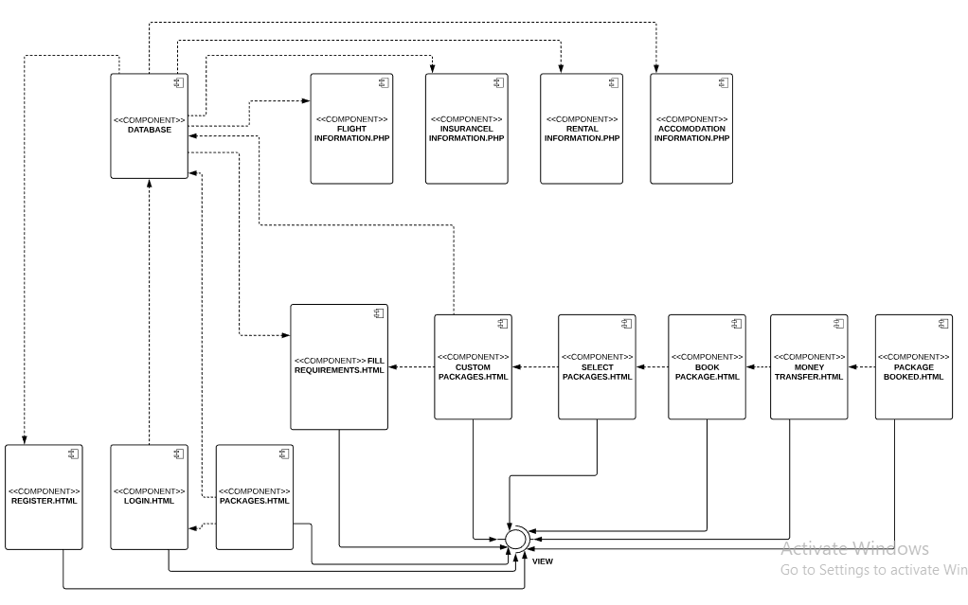

**4.** **10. Deployment Diagram**

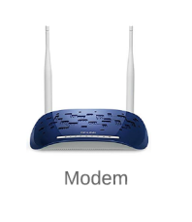 **Nodes** 